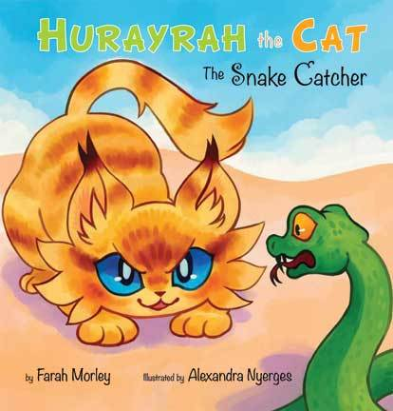

Islamic studies

* Discuss the importance of Madinah
* Learn the Adhan
* Learn about Abu Huraryah and hadiths
* Learn about Qaswa in more detail

Science

* Grouping animals (using the animals featured in the story)
* Water cycle (linked to Oasis in the story)

Art

* Create a desert scene with an oasis
* Draw a cat
* Make a 3d market place using cardboard boxes

Hurayrah the Cat: The Snake Catcher

Geography

* Madinah (look at the country and continent it’s in)

Literacy

* Speech marks - write using speech marks: what could the doves in the story have said.
* Retell the story using small drawings: write sentences under each one to retell story
* Order the story: using small images order the story
* Frontal adverbs (using the example in the book -adapt the sentence)
* Write a list using commas (what they could have sold at the market)
* Character description
* Setting description
* Reading comprehension